Donegal Local Development CLG
Enterprise Officer – Specified Purpose Contract (Maternity)
Donegal Local Development CLG is an integrated local development company established in 1995. We deliver a number of external funded programmes to the Donegal community. Donegal Local Development CLG (DLDC) are now inviting applications for the position of Enterprise Officer, Full Time, as part of its SICAP 2018 – 2022 Programme. This is a six- month fixed term position, which may be extended subject to funding.

The successful candidate will be required to work as a member of the Enterprise Team to support unemployed people set up their own business. A minimum of three years’ relevant experience or a third level qualification in Business or Accountancy is required.

To apply for the position, please submit by email a Letter of Application together with current Curriculum Vitae to: HR Department, Donegal Local Development CLG, 1 Millennium Court, Pearse Road, Letterkenny, Co. Donegal to: vacancies@dldc.org

Applications to arrive no later than Monday 9th May 2022. Job Descriptions are available from vacancies@dldc.org and also on the DLDC website www.dldc.org Interviews are likely to take place week beginning 16th May 2022. We reserve the right to enhance the shortlisting criteria. A panel may be formed from which similar vacancies may be filled.

Donegal Local Development CLG is committed to a Policy of Equal Opportunity.
Canvassing will disqualify.

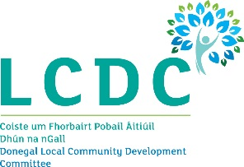
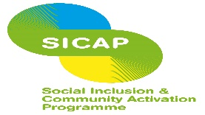
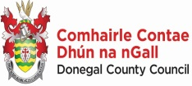

“The Social Inclusion and Community
Activation Programme (SICAP) 2018-2022 is funded by the Irish Government through the Department of Rural and Community Development and co-funded by the European Social Fund under the Programme for Employability, Inclusion and Learning (PEIL) 2014-2020

