**Forbairt Áitiúil CLG Dhún na nGall**

**Oifigeach Fiontair (Páirtaimseartha) – Conradh do Chuspóir Sonraithe**

Is comhlacht forbartha comhtháite áitiúil é Forbairt Áitiúil CLG Dhún na nGall a bunaíodh sa bhliain 1995. Cuirtear ar fáil roinnt clár atá maoinithe go seachtrach do phobal Dhún na nGall. **Tá Forbairt Áitiúil CLG Dhún na nGall (DLDC)** anois ar lorg iarratais don phost mar **Oifigeach Fiontair, Páirtaimseartha**, mar chuid dá Chlár SICAP 2018 – 2022. Is é seo post ar feadh téarma seasta sé mhí a d’fhéadfaidh a leathnú, ag brath ar mhaoiniú.

Beidh ar an iarrthóir rathúil oibriú mar bhall den Fhoireann Fiontair chun tacú le daoine dífhostaithe á ngnólacht féin a bhunú. Tá íosmhéid trí bliana de thaithí ábhartha nó cáilíocht triú leibhéal i nGnó nó i gCuntasaíocht de dhíth. Táthar ag súil go mbeidh an ról seo lonnaithe san oifig i nGaoth Dobhair agus tá sé oscailte do chainteoirí líofa Gaeilge agus dóibh siúd atá cumasach á gcuid oibre a dhéanamh tríd an teanga Ghaeilge.

Chun iarratas a dhéanamh ar an phost, **cuir Litir Iarratais le ríomphost maraon le Curriculum Vitae reatha chuig**: Roinn na Acmhainní Daonna, Forbairt Áitiúil CLG Dhún na nGall, 1 Cúirt na Mílaoise, Bóthar an Phiarsaigh, Leitir Ceanainn, Co. Dhún na nGall chuig: vacancies@dldc.org le do thoil.

Caithfidh na hiarratais a bheith istigh ar nó roimh an **Luain 21 ú Feabhra 2022**. Tá Cur Síos ar Phoist ar fáil ó **vacancies@dldc.org** agus lena chois sin ar shúiomh gréasáin an DLDC www.dldc.org. Is dócha go dtarlóidh na hagallaimh sa tseachtain ag toiseacht ar an 28th Feabhra 2022. Coinníonn muid an ceart na critéir gearrliostála a mhéadú. Féadfar painéal a chruthú óna líonfar folúntais mar an gcéanna.

***Tá Forbairt Áitiúil CLG Dhún na nGall tiomanta do Pholasaí um Deiseanna Comhionann.***

***Beidh canbhasail ina chúis le dícháiliú.***

**Donegal Local Development CLG**

**Enterprise Officer (Part Time) – Specified Purpose Contract**

Donegal Local Development CLG is an integrated local development company established in 1995. We deliver a number of external funded programmes to the Donegal community. **Donegal Local Development CLG (DLDC)** are now inviting applications for the position of **Enterprise Officer, Part Time,** as part of its SICAP 2018 – 2022 Programme. This is a six- month fixed term position, which may be extended subject to funding.

The successful candidate will be required to work as a member of the Enterprise Team to support unemployed people set up their own business. A minimum of three years’ relevant experience or a third level qualification in Business or Accountancy is required. This role is expected to be based in the Gweedore office and is open to fluent Irish speakers and to people who are capable of doing their work through the Irish language.

To apply for the position, **please submit by email a Letter of Application together with current Curriculum Vitae** to: HR Department, Donegal Local Development CLG , 1 Millennium Court, Pearse Road, Letterkenny, Co. Donegal to: [**vacancies@dldc.org**](mailto:vacancies@dldc.org)

Applications to arrive no later than **Monday 21st February 2022**. Job Descriptions are available from [vacancies@dldc.org](mailto:vacancies@dldc.org) and also on the DLDC website [www.dldc.org](http://www.dldc.org) Interviews are likely to take place week beginning 28th February 2022. We reserve the right to enhance the shortlisting criteria. A panel may be formed from which similar vacancies may be filled.

***Donegal Local Development CLG is committed to a Policy of Equal Opportunity.***

***Canvassing will disqualify.***

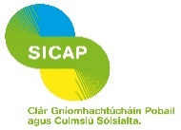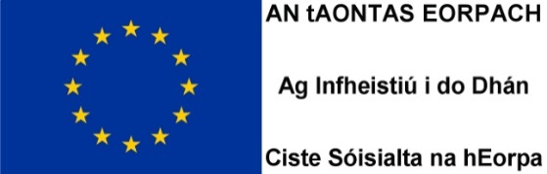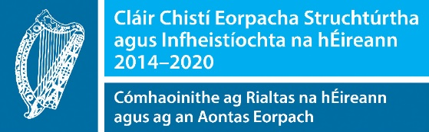

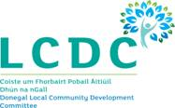

*Tá An Clár Gníomhachtúcháin Pobail agus Cuimsiú Sóisialta (SICAP) 2018-2022 á mhaoiniú ag Rialtas na hÉireann tríd an Roinn Forbartha Tuaithe agus Pobail, agus á chomh-mhaoiniú ag Ciste Sóisialta na hEorpa faoin Chlár um Infhostaitheacht, Cuimsiú agus Foghlaim (PEIL) 2014-2020.*