Who can make a nomination?
The awards are open to anyone who meets the criteria of the related category.

Is there any cost to enter?
No – it’s completely free to enter the Community Recognition Awards.

Can I nominate myself or my own organisation?
Yes - we accept self-nominated and third party entries for both organisations and individuals.

How many submissions can be made for the same individual or organisation?
There are no limits to how many unique submissions can be made by an individual or organisation as long as they meet the eligibility requirements for the category.

Can I nominate someone from any part of Donegal?
To be eligible for nomination in the DLDC Community Recognition Awards, nominees must be operating in the areas identified as Lot 2 or Lot 3 on the map below. This is due to the public funding contract under which the relevant public funding budget is held. This is without prejudice to other community & voluntary organisations / Social Enterprises within Donegal.

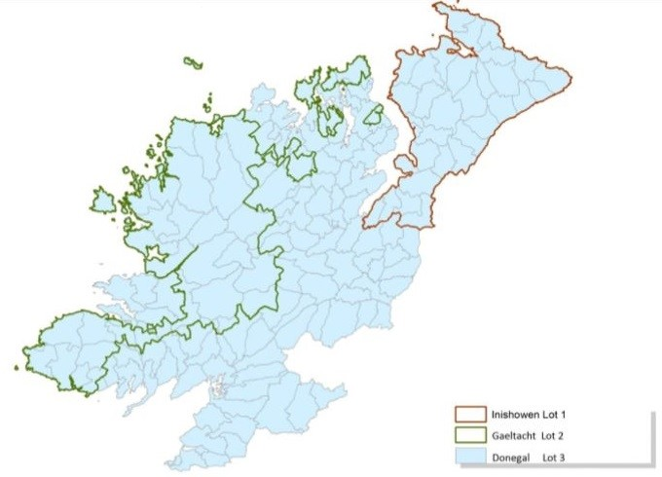

I’m not sure if the group I’m nominating is a small organisation or large organisation. What should I do?
Take your best guess. If we think it’s in the wrong category, we’ll re-allocate it to the correct category for you.

How do I nominate?
Easy – just visit www.dldc.org/awards and complete the online nomination form. You’ll get an on-screen notification and an email to confirm we’ve received your entry.

What is the closing date for nominations?
The closing date for nominations 5pm on Wednesday 6th of October 2021.

What are the eligibility criteria for each category?
Category | Criteria
Best Social Inclusion/Peer Support Campaign | - The campaign must have a social inclusion or peer support focus.  - Examples of groups in this space include active retirement groups, Men’s Sheds, women's groups, carer’s groups, community gardens, etc.  - The campaign must have taken place in Donegal.
Special Recognition Award – A Community Response to Covid-19 | - This award is for a community as a whole – not for individuals or individual organisations.  - The award is specifically for their response to Covid-19.  - The community must be in Donegal.
Best Community Organisation - Small | - The organisation must have an annual income of less than €100,000.  - The organisation must be a not-for-profit.  - The organisation must be based in Donegal (or operate in Donegal).
Best Community Organisation – Large | - Organisation must have an annual income of more than €100,000  - The organisation must be a not-for-profit.  - The organisation must be based in Donegal (or operate in Donegal).
Lifetime Achievement Award – Individual Award | - This award is for individuals only (no organisations).  - The individual must be based in Donegal (or operate in Donegal).

Can I enter more than one category?
Yes, you can enter as many categories as you want. Just make sure that you meet the eligibility criteria for each category before submitting.

How are the winners determined?
The judges score the entries. The winner will be the entry with highest score. If there is only 1 entry for a category then judges will be asked to recommend whether any award should be made or not.

When and where are the Awards?
The event is taking place in the Finn Valley Centre, Stranorlar at 7pm on Thursday, 4th November 2021.

What is the dress code for the awards?
The dress code is smart casual.

Can I bring anyone with me if I’m nominated?
Each shortlisted nominee will be provided with 3 free tickets to the event.
Please note this is a ticket only event with limited numbers of tickets available for successful nominations.

Can I buy tickets if I’m not nominated?
Due to Covid-19 guidelines, additional tickets will not be available in order to maintain social distancing.

What organisations are the judging panel from?
The judging panel are from the following organisations:
- Highland Radio
- Pramerica
- LYIT
- Letterkenny Chamber of Commerce
- Watson Hire
