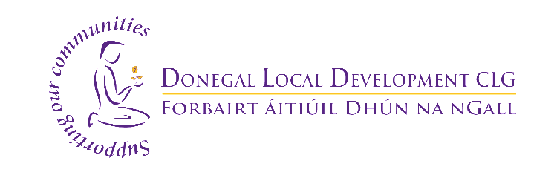

Application for Community Organisations to host a LEADER Idea Centre

Donegal Local Development CLG is seeking applications from community based organisations in the Central Donegal Area who may be interested in hosting a Social Innovation Hub within their premises known as a LEADER Idea Centre. (Refer to ‘LEADER Idea Centre – Criteria’ for details of the extent of the Central Donegal Catchment area)
The LEADER Idea Centre shall be a space to facilitate the provision of training to a range of community groups and individuals to develop unique and innovative projects to achieve their goals and objectives.
The LEADER Idea Centre forms part of the Innovating Communities Programme which is a programme being delivered in counties Donegal, Cavan, Monaghan, Sligo, Louth and Leitrim with an aim to support communities to develop viable but creative and imaginative projects, solutions and ideas and will run until October, 31st 2022.
Criteria to become a LEADER Idea Centre is included below.
If your organisation is interested in hosting a LEADER Idea Centre please complete the Application form below and email to mlarkin@dldc.org

For further information, please contact Margaret Larkin on 087 7633790.

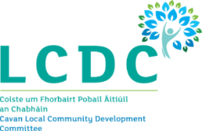
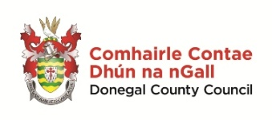
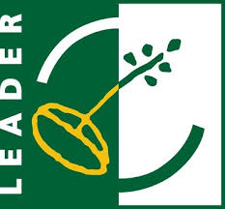

We wish to acknowledge the project funding being provided by the Donegal LEADER Local Action Group under the LEADER Programme, the Department of Rural and Community Development under the National Rural Development Programme 2014-2020 and the European agricultural fund for rural development 2014-2020.

LEADER Idea Centre – Criteria
Introduction
The Innovating Communities Programme (ICP) is a training programme aimed at harnessing a rural population that is open to new ideas and ways of working. The participants will be trained using a process called ‘Design Thinking’ which is primarily about equipping local communities to arrive at innovative solutions to local problems. The ICP will be delivered in counties Donegal, Sligo, Leitrim, Cavan, Monaghan and Louth.

The principal programme outcomes are outlined below.

Outcome 1 - The first outcome of the programme is to provide 2 innovation hub spaces in each county called LEADER Idea Centres as a means of establishing Rural Innovation capacity that can be enhanced throughout the life of the programme.

Outcome 2 - An external organisation Ice Cream Architecture has been contracted to provide the necessary specialist training capacity in each Hub.

Outcome 3 - The third outcome of the programme will be the number of people trained in ‘Design Thinking’.
In the Central Donegal Area a total of 17 training courses will be delivered over the period ending December 31st 2022. 10 of these courses will be Design Sprint Modules with 21 hours of training delivered while 7 will be Full Scale Modules with 42 hours of training delivered. Based on an average of 12 participants per module, there will be 150 participants trained over the course of the programme. It is expected that there will be 504 hours of face to face training delivered in Central Donegal in total however in response to public health restrictions this may have to be amended accordingly.
A total of 105 training courses will be delivered across the 6 partnering counties. 60 of these courses will be Design Sprint Modules and 45 will be Full Scale Modules. This equates to an average of 1,260 participants trained over the course of the programme with approximately 3150 hours of face to face training delivered – depending on restrictions.

Outcome 4 - Ice Cream Architecture along with their own panel of trainers will train 24 co-trainers from the local community through an accredited training programme i.e. 4 local trainers in each county. When the programme is complete the local trainers can use the learning and experience gained to lead future training and build further capacity and capability for development of new innovative projects.

Premises/Hub Location
One of the central underpinnings of the ICP is to find innovative local solutions for local people. Therefore, to be effective the programme and individual training modules must be delivered locally. To this end, it is viewed as essential to provide local focal points in each area where innovation can be fostered, trainers and co-trainers can use as a base of operations and events / workshops may be held for the training activities and programmes. To achieve this, the project will re-purpose 2 community spaces per county into more innovation-conducive / accessible spaces. It is proposed that these spaces or hubs will be called ‘LEADER Idea Centres’. As the LEADER Idea Centre will not be utilised on a full time basis the host facility will be able to use the space for other activities when the hub is not in use. It is proposed that Central Donegal shall have 1 ‘LEADER Idea Centres’ located in South Donegal and 1 in North East Donegal.

Key features of these LEADER Idea Centres are:
- They have their own brand and identity as learning spaces or living labs
- Idea Centres provide innovative space for learning teams, more specialist provision requiring specialist equipment will be signposted
- 2 Idea Centres per county will be set up, providing capacity for future Innovating Communities development
- A single point of contact and a Charter will be created for each Idea Centre
- A target level of utilisation will be set for their use as part of Innovation Projects
- Represent a great opportunity for Communities, Schools and Young Innovators
- A LEADER Idea centre may be mobile in nature and rotate between a number of community facilities based on local need and demand.

Requirements for LEADER Idea Centres under the context of this programme are:
- Located in accessible centres to allow for geographical spread in each county
- Minimum 40m² with wi-fi and access to kitchen facilities (adhering to current public health guidelines for a safe training environment)
- A well-equipped training room as some equipment will be provided by under the ICP programme.
- Capable of hosting group training by Specialist Trainer.
- Shared spaces as part of an existing community building
- The Idea Centres need to be flexible with opening hours to facilitate evening or weekend learning
- Must be able to adhere to appropriate Health and Safety requirements, especially in relation to HSE Covid 19
- Capable of being a working space or training space
- Act as a regular venue for groups needing an innovative space either in a group or individual space.

A Fee shall be paid to the host Community organisations on a per hour room hire only basis and the space can be utilised by the host organisation when not in use for training purposes.

To be selected as a potential hub for the implementation of the Innovating Communities Programme (ICP) please complete the form attached with this guidance document.

Partners
Innovating Communities is an inter-territorial co-operation training programme funded under the LEADER cooperation measure led by Monaghan Integrated Development CLG and includes Donegal Local Development CLG, Louth LEADER Partnership CLG, Leitrim Integrated Development Company CLG, County Sligo LEADER Partnership Company CLG, and Breffni Integrated Development CLG. The partners are implementing the programme on behalf of their respective LEADER Local Action Groups. The Implementing Partners are also supported by South West College as the Project’s Academic Partner.

Central Donegal Catchment Area
To be eligible to apply to become a ‘LEADER Idea Centre’ applicants must be operating in the area identified as Lot 3 on the map below. This is due to the public funding contract under which the relevant grant budget is held. This is without prejudice to the needs of other organisations within Donegal, however the specific fund and budget is only available under one public funding contract within the County in 2021.

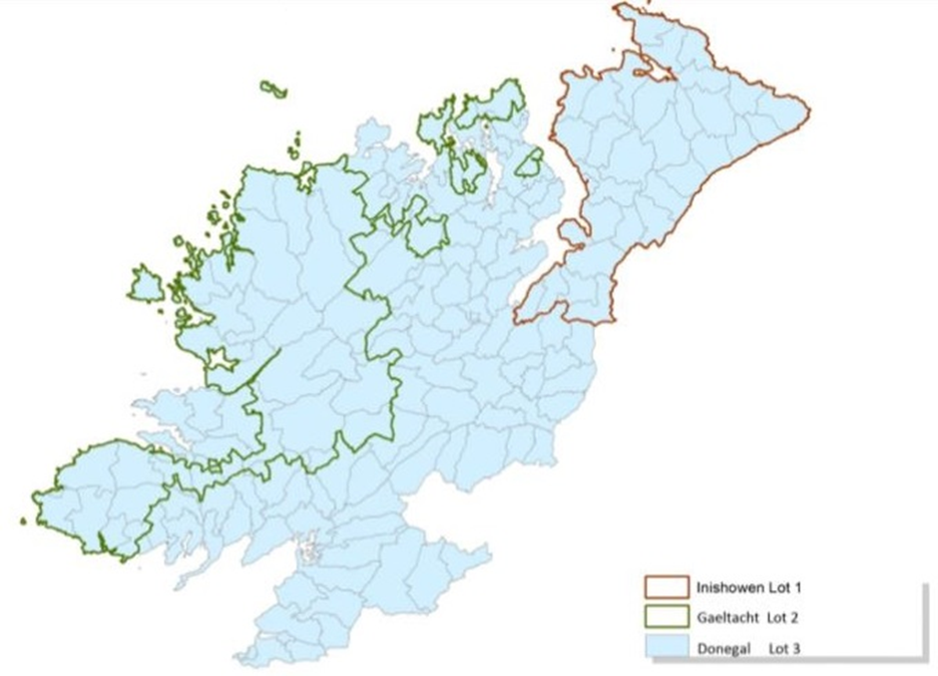

LEADER Idea Centre – Application form
Details of Organisation
Organisation Name:
Organisation Address:
Contact Name:
Contact telephone Number:
Contact email:

Broadband

Do you have reliable high speed broadband?  Please provide details of broadband Speed and Type e.g Satellite, Fibre etc | Speed |  | Type
Training Room Space

Do you have a space to accommodate up to 14 people for training which meets the public health guidelines? | Yes |  | No
Proposed room size? Sq metres / Sq feet
Does the room have adequate light & heat? | Yes |  | No
Access & Accessibility

Does your Facility have the following:
Disability access: | Yes |  | No
Toilet facilities: | Yes |  | No
Handwashing Facilities: | Yes |  | No
Canteen facilities: | Yes |  | No
Caretaker Onsite: | Yes |  | No
Onsite Parking: If yes please provide number of parking spaces available. | Yes | No |  | No. of Spaces
Facility Opening Hours | From |  | To
Equipment & furnishings

ICT Equipment and furnishings will be provided under the programme and will remain the property of the Local Development Company. Do you commit to the safe storage of property of the LAG? | Yes |  | No

Insurance

The ICP will require indemnification under the existing insurance policy of each LEADER Idea Centre location. Do you agree to this requirement? | Yes | No
Health & Safety

Do you have a current Health & Safety Statement: | Yes | No
Is the Health & Safety statement in compliance with public health guidelines for community facilities | Yes | No
Future Commitment
Can you commit a training space for up to 3 hours twice per week? | Yes | No
Is the community organisation interested in the concept of social innovation and willing to commit to its future sustainability post programme implementation by making the LEADER Idea Centre permanently accessible to community groups? | Yes | No
Local Environment
Please provide a brief statement under the following headings:
Estimated Local population (size and diversity):
Local Community groups, resources, capacity and activity to sustain the hub:

NOTE: Submission of this application may also include a site visit to verify the information provided within this application. .
Signed on behalf of the Organisation: | Date:

